GLOBAL OLYMPIC SPORTS PERFORMANCE ANALYSIS
Project Documentation
Team ID: Individual
Prepared from the confirmed project details and current Tableau dashboard views. Items requiring live testing evidence, screenshots, or external links are clearly identified rather than fabricated.

1. INTRODUCTION

1.1 Project Overview
Global Olympic Sports Performance Analysis is a data-visualisation project that explores Olympic medal performance across countries, medal types, seasons, and years. The project uses Tableau Public to present medal-related information through interactive charts and a country filter.

1.2 Purpose
The purpose is to make Olympic performance data easier to explore, compare, and interpret. A visual dashboard can help users identify leading countries, compare gold/silver/bronze medals, examine Summer versus Winter Olympic performance, and view medal trends over time.

2. IDEATION PHASE

2.1 Problem Statement
Olympic results can be difficult to interpret when presented only as large tables. Users may need to compare countries, medal categories, seasons, and historical trends across many records. The project addresses this by organising key comparisons into a single interactive visual experience.

2.2 Empathy Map Canvas
Says: “I want to know which countries perform best and how medal totals change over time.”
Thinks: “Comparisons should be clear, consistent, and easy to filter.”
Does: Selects a country, compares medal categories, and examines season and year trends.
Feels: More confident when patterns are presented visually instead of buried in rows of data.
Pains: Large tables, difficult country-to-country comparisons, and trends that are hard to notice.
Gains: Quick visual comparisons, an overview of medal leaders, and easier exploration of Olympic history.

2.3 Brainstorming
Ideas considered for the dashboard include a top-country ranking, medal-type comparison, Summer/Winter comparison, historical trend line, and a country filter. These ideas are represented in the current dashboard views.

3. REQUIREMENT ANALYSIS

3.1 Customer Journey Map
Discover: User opens the Tableau Public dashboard and reads the chart titles.
Explore: User reviews the Top 10 Countries chart and Medal Comparison chart.
Filter: User selects a country using the available country filter.
Compare: User examines Olympic Season Performance and the medals trend over time.
Understand: User draws conclusions from the visible comparisons, keeping in mind the scope and completeness of the source data.

3.2 Solution Requirement
Functional requirements: display top countries; compare bronze, gold, and silver medals; compare Summer and Winter performance; show medal trends over time; and allow country filtering. Non-functional requirements: chart titles and labels should be understandable, the layout should remain readable, and interactions should respond reliably. Actual performance targets should be set after measuring the live dashboard.

3.3 Data Flow Diagram
High-level flow: Olympic medal summary CSV (medal_table_summary.csv) → data inspection and preparation → Tableau data source → chart construction and country filter → interactive dashboard → user interpretation. The diagram is a logical representation; detailed ingestion steps depend on the actual workbook and data-preparation workflow.

3.4 Technology Stack
Confirmed: Tableau Public for visualisation and the CSV file medal_table_summary.csv as the displayed data source. Supporting work may use spreadsheet or data-preparation tools, but specific additional tools are not asserted without evidence.

4. PROJECT DESIGN

4.1 Problem–Solution Fit
Problem: Olympic performance information can be cumbersome to compare in tabular form. Solution: a consolidated interactive dashboard. Target users: students, sports followers, and users interested in country-level Olympic medal patterns. Value: faster visual comparison and clearer trend exploration. Validation status: the dashboard views are known, but formal user-test results have not been provided.

4.2 Proposed Solution
Create a Tableau Public dashboard containing four confirmed views: Top 10 Countries (horizontal bar chart), Medal Comparison (Bronze/Gold/Silver), Olympic Season Performance (Summer/Winter), and Olympic Medals Trends Over Time (line chart), with a country filter.

4.3 Solution Architecture
Source layer: medal_table_summary.csv. Analysis layer: Tableau data connection and any transformations configured in the workbook. Visualisation layer: four charts and country filter. Presentation layer: Tableau Public dashboard. User interaction: filter selection and visual comparison. Exact calculated fields and transformations should be documented from the final workbook.

5. PROJECT PLANNING & SCHEDULING

5.1 Project Planning
Suggested work sequence: (1) confirm business questions and source fields; (2) inspect and prepare the CSV; (3) build the four views; (4) arrange the dashboard and configure the country filter; (5) validate calculations and interactions; (6) measure performance; (7) capture final screenshots and prepare documentation. Record actual owners, dates, and completion status in the team’s planning sheet; no unverified completion dates are stated here.

6. FUNCTIONAL AND PERFORMANCE TESTING

6.1 Performance Testing
Functional checks: verify each chart loads, medal categories are represented correctly, Summer/Winter comparisons use the intended fields, the trend axis uses the correct year/date field, and the country filter updates the relevant views. Performance checks: record initial dashboard load time, filter response time, and any slow queries on the actual device/network. Test results, measured timings, data row counts, and screenshots were not supplied, so they must be entered after running the tests.

7. RESULTS

7.1 Output Screenshots
Final Tableau output screenshots of the 3 dashboards and the Story are shown below.
Dashboard 1 — Global Olympic Performance
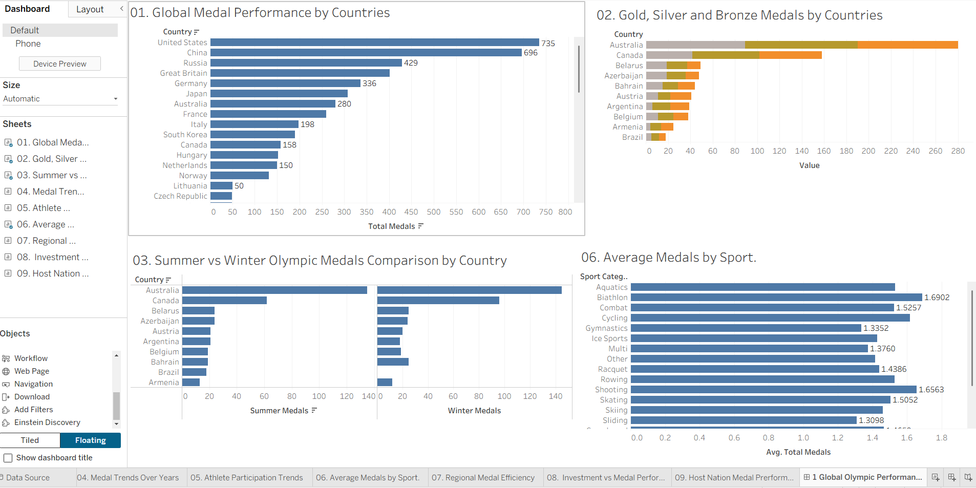
Dashboard 2 — Investment and Regional Efficiency
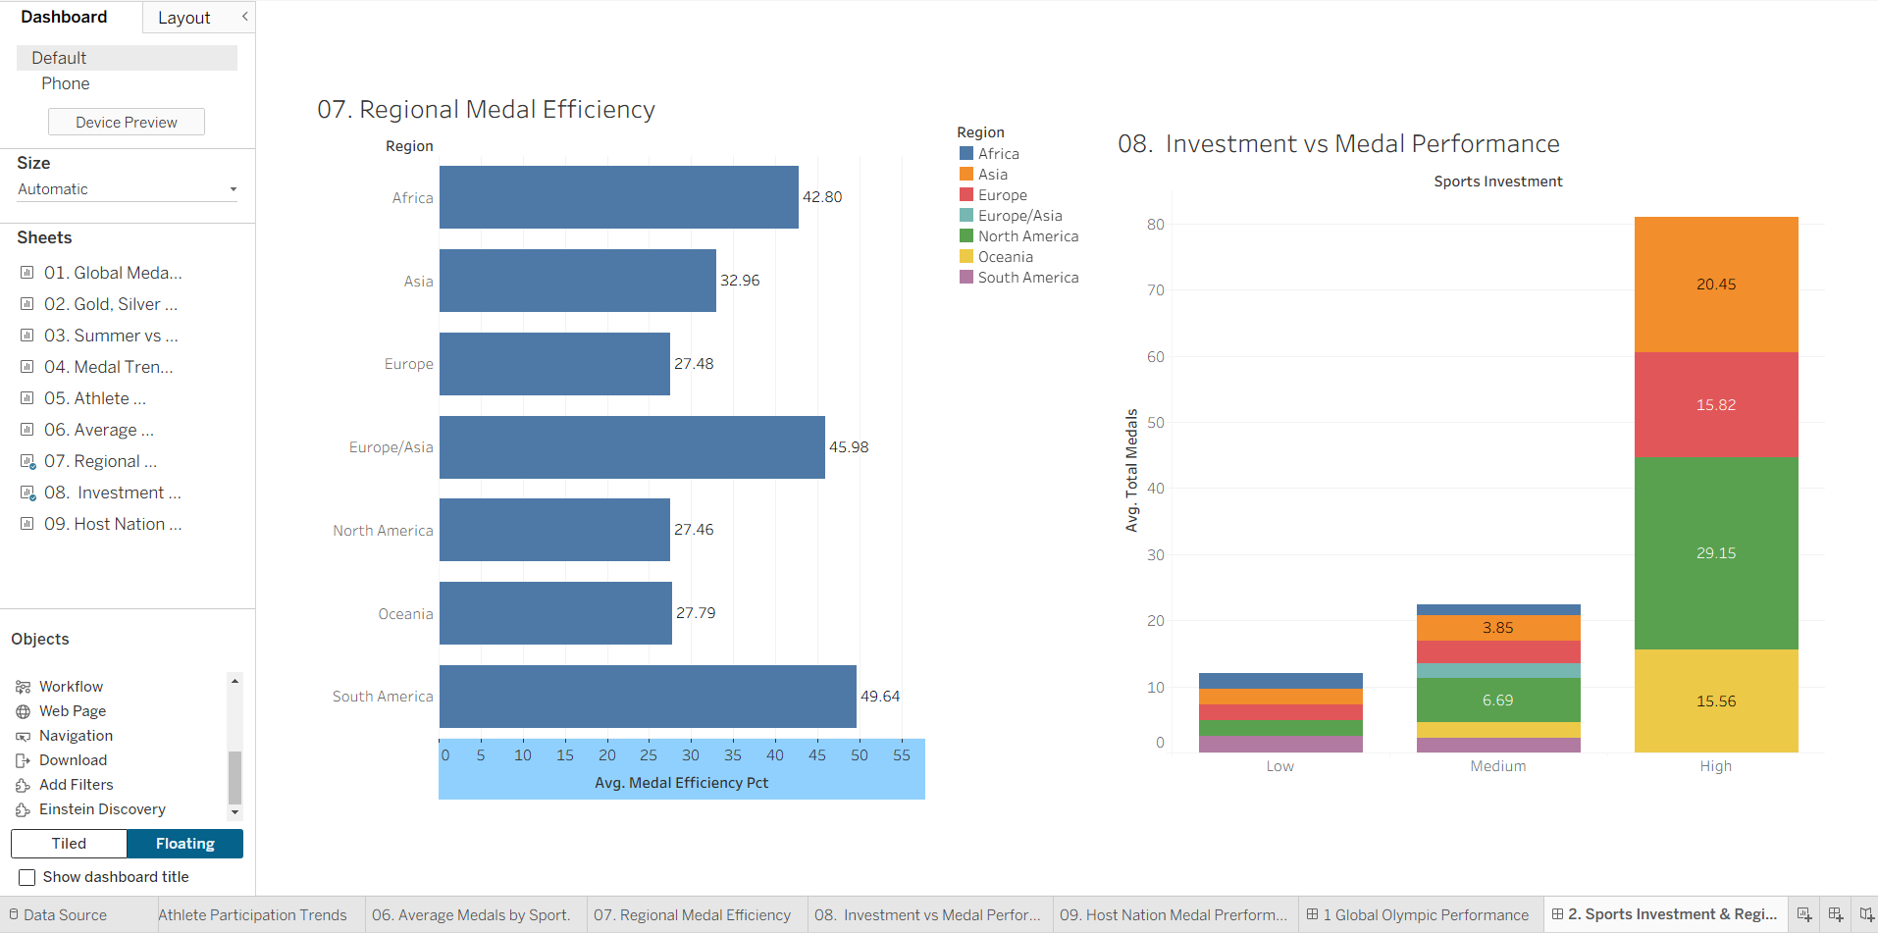
Dashboard 3 — Olympic Trends
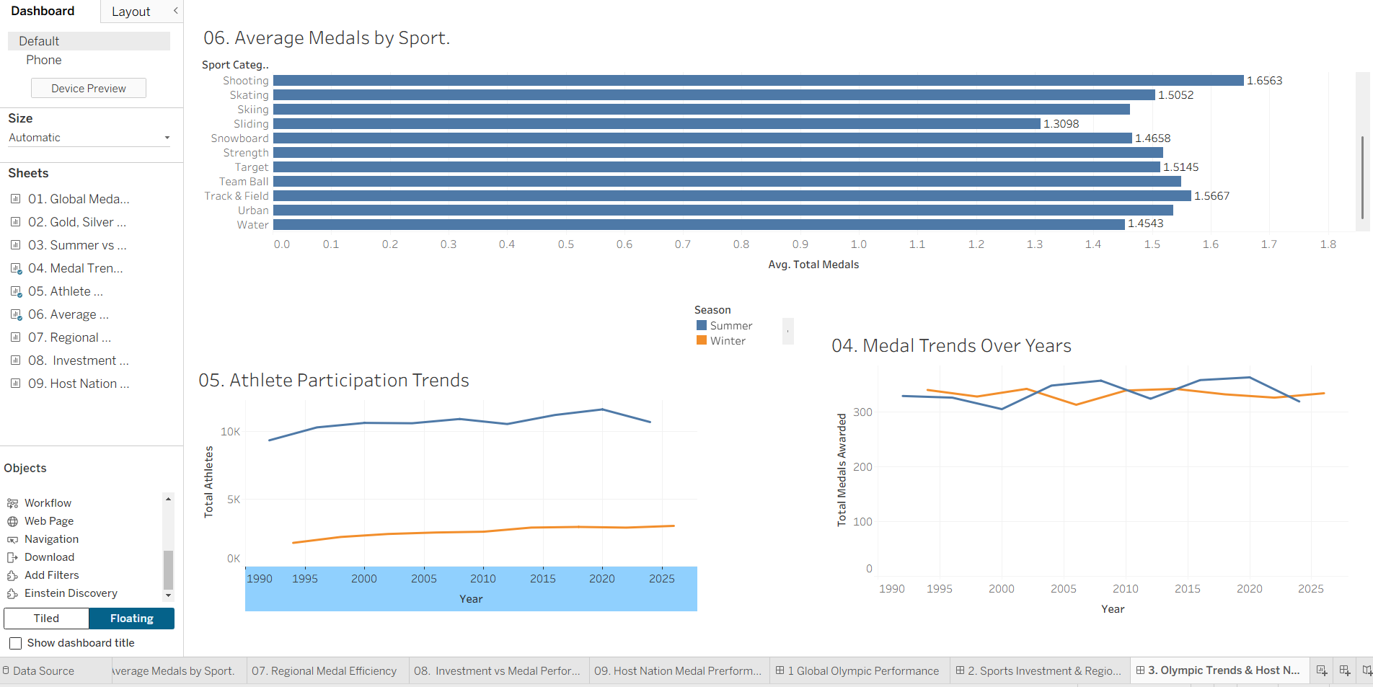
Story — Scenario 1 (Ms. Priya)
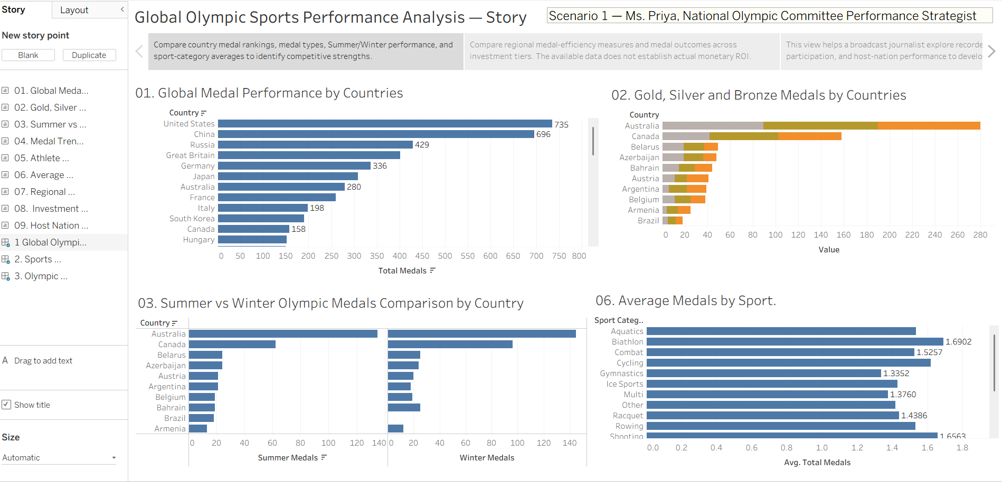
Story — Scenario 2 (Mr. Carlos)
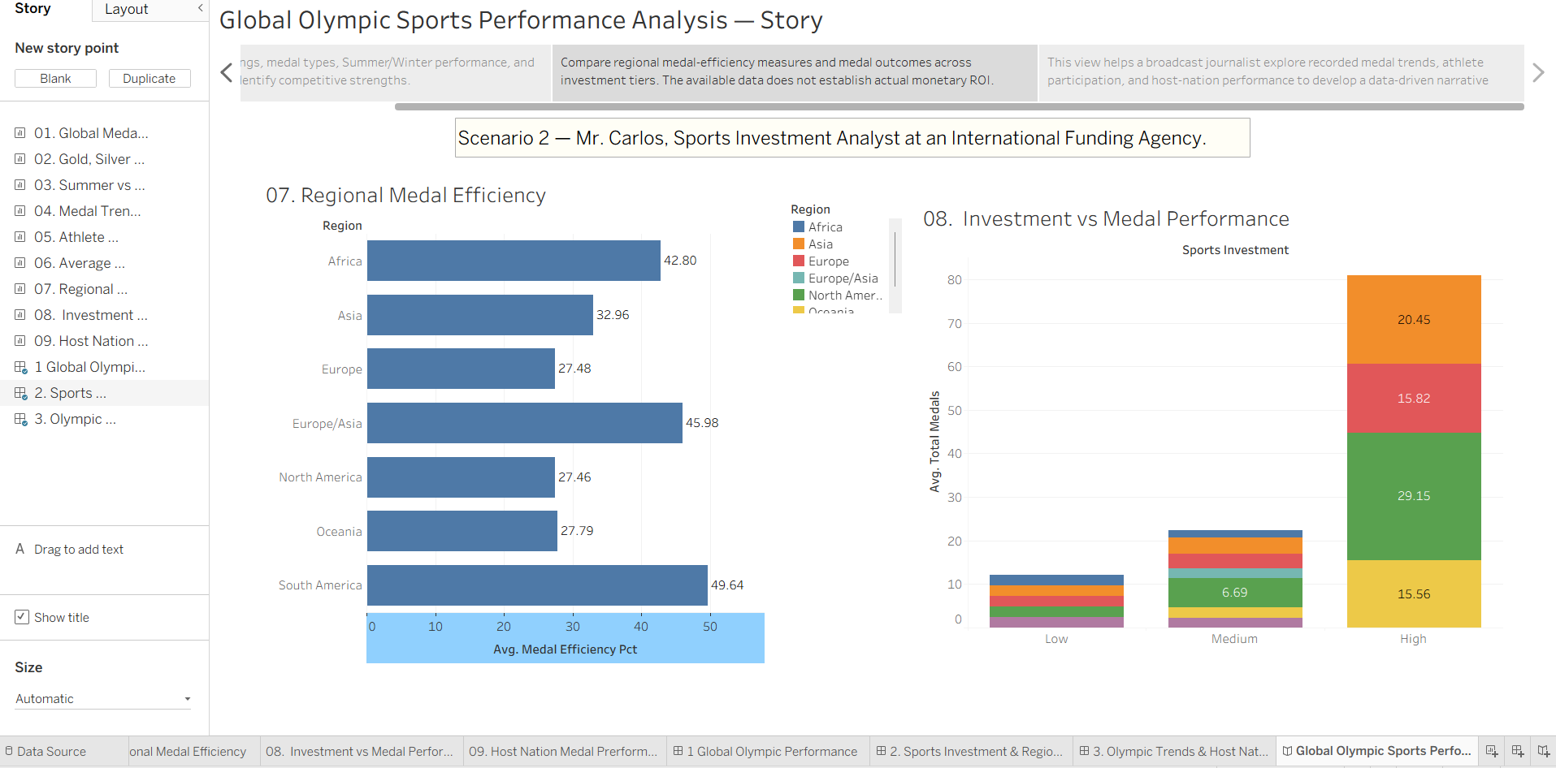
Story — Scenario 3 (William Robert)
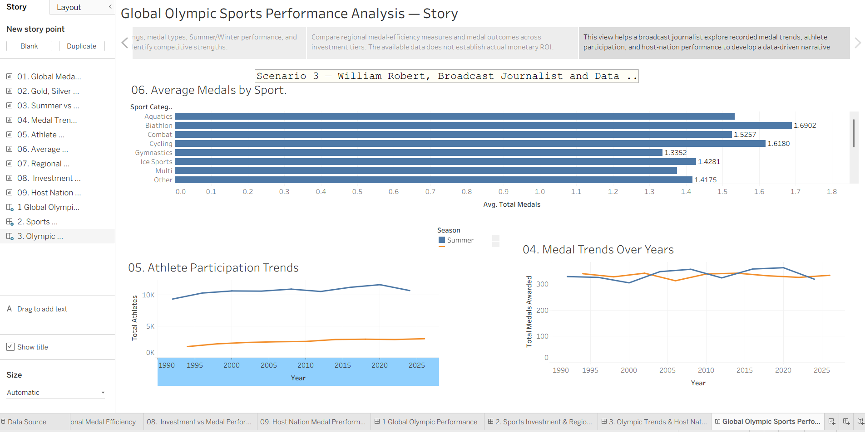

8. ADVANTAGES & DISADVANTAGES
Advantages: interactive exploration; quick country ranking; medal-category comparison; seasonal comparison; historical trend view; and a consolidated presentation.
Disadvantages/limitations: insights depend on the accuracy and coverage of the source data; a Top 10 chart does not show every country at once; aggregated views may hide event-level detail; and interpretation can be affected by differences in Olympic participation and the number of events across eras.

9. CONCLUSION
The project demonstrates how Tableau Public can turn Olympic medal summary data into an accessible dashboard. The four confirmed visualisations address country ranking, medal-type comparison, seasonal performance, and trends over time. Final conclusions should be supported by the actual data and verified dashboard output.

10. FUTURE SCOPE
Potential extensions include filters for year, sport, gender, and host country; event-level drill-down; per-capita or participation-adjusted comparisons; data-quality checks; accessibility improvements; mobile layout optimisation; and a documented refresh process for updated datasets.

11. APPENDIX

Source Code (if any)
No separate source-code repository or script was provided. Tableau workbook calculations and data transformations, if any, should be attached or described here.

Dataset Link
Dataset file shown in the project: medal_table_summary.csv. Public download URL and dataset provenance were not provided; add the verified source link before submission.

GitHub & Project Demo Link
GitHub repository: https://github.com/richachhatri09/Global-Olympic-Sports-Performance-Analysis.git
Tableau Public demo (Story) URL: https://public.tableau.com/views/olympic07/GlobalOlympicSportsPerformanceAnalysisStory?:language=en-US&publish=yes&:sid=&:redirect=auth&:display_count=n&:origin=viz_share_link
Planned 9 Tableau Worksheets
The following worksheet plan aligns with the three supplied stakeholder scenarios. These are planned views; final screenshots and exact results must be inserted after each worksheet is built and validated in Tableau Public.
Sheet | Chart | Chart type | Dataset / key fields | Scenario
Sheet 01 | Global Medal Performance by Country | Horizontal bar | alltime_country_rankings.csv: country; total_medals | Priya
Sheet 02 | Gold, Silver and Bronze Medals by Country | Stacked horizontal bar | alltime_country_rankings.csv: country; total_gold; total_silver; total_bronze | Priya
Sheet 03 | Summer vs Winter Olympic Medal Comparison | Side-by-side bars | alltime_country_rankings.csv: country; summer_medals; winter_medals | Priya
Sheet 04 | Total Medals Awarded Over the Years | Line | games_summary.csv: year; total_medals_awarded; season | William Robert
Sheet 05 | Athlete Participation Trends Across Olympic Games | Line | games_summary.csv: year; total_athletes; season | William Robert
Sheet 06 | Average Medals per Athlete by Sport Category | Horizontal bar | athletes.csv: sport_category; AVG(total_medals) | Priya
Sheet 07 | Average Medal Efficiency by Region | Bar | medal_results.csv: region; AVG(medal_efficiency_pct) | Carlos
Sheet 08 | Average Medal Performance by Sports Investment Tier | Bar | medal_results.csv: sports_investment; AVG(total_medals); region (optional color) | Carlos
Sheet 09 | Host-Nation Medal Performance Across Games | Bar | medal_results.csv: year; host_country; country; total_medals; host_nation | William Robert
Planned 3 Dashboards
Dashboard arrangement is planned as follows; publish links and screenshots remain to be added after the workbook is completed.
Dashboard | Worksheets | Purpose
Dashboard 1 — Global Olympic Performance | Sheets 1, 2, 3, 6 | Country medal rankings, medal-type composition, Summer/Winter comparison, and sport-category average medal counts.
Dashboard 2 — Investment and Regional Efficiency | Sheets 7, 8 | Regional average recorded efficiency and medal outcomes by investment tier; no monetary ROI claim.
Dashboard 3 — Olympic Trends and Host Nations | Sheets 4, 5, 9 | Recorded medal trends, athlete participation, and host-nation performance.
Project Date and Status
Documentation date: 27 October 2026. The 9 worksheets, 3 dashboards and 1 Tableau Story are completed and published on Tableau Public; the GitHub repository and Tableau Public Story links are added above. Measured performance timings are not recorded.

